P1.583 Indoor HD Full Color LED Display Parameters
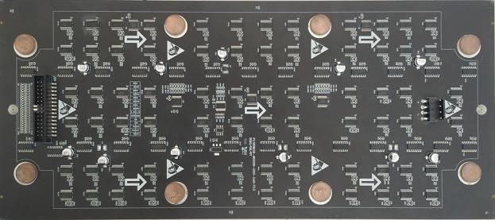
LED Light
LED | LED Lamp | LED Type | Wavelength（nm） | Average Brightness | Test Condition
RED  （R） | Nationstar | SMD  1010 | 620-625nm | 130-190mcd | 25℃,20mA
GREEN（G） |  |  | 520-525nm | 200-300mcd | 25℃,10mA
BLUE（B） |  |  | 470-475nm | 23-40mcd | 25℃,5mA
二．Pixels/Modules
No | Serial | Parameters
1 | Pixel Pitch | 1.583mm
2 | Pixel Configuration | 1R1G1B R：G：B=3：6：1
3 | LED Lamp | Full Color
4 | Density | 398908 dot/㎡
5 | Module Size | 342x152mm
6 | Module Pixel | 216*96=20736 dot
7 | Module Thickness | 3mm
8 | Module Power | ≤20.8W
9 | Driving Voltage | DC5V
10 | Module Current | 4.2A

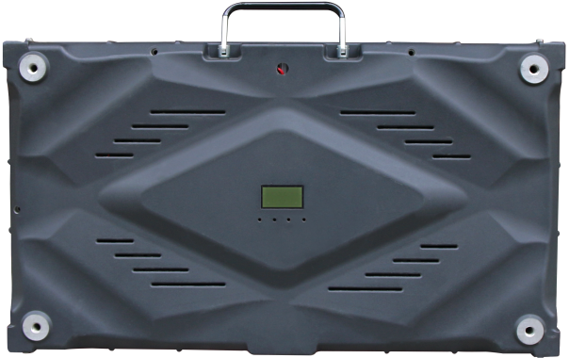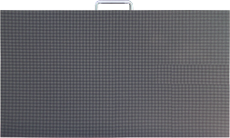

三．Screen Parameters
No | Serial | Technic Parameters
1 | Standard Cabinet Size | 608mm*342mm*60mm (16:9)
2 | Single Cabinet Weight | 7.35KG
3 | Brightness/Adjustment | ≥500cd/㎡ Level 16- Automatic / Level 100-Manual operation)
4 | View Angle | ≥160°（Horizontal），≥160°（Vertical）
5 | Best View Distance | ≥2m
6 | Grey Level | ≤65536
 | Color Temperature | 8000K
7 | Frame Frequency | ≥60Hz
8 | Refresh Rate | ≥3840Hz
9 | Signal Input/ Control Mode | Video、VGA/Computer Control，Video Synchronization，Real time Display
10 | Driving Mode | 1/108 Scan
11 | Driving IC | Standard Configuration
12 | Module Quantities/ Sqm | 19.24
13 | Display Colors | 16777216
14 | Continue Working Time | >24（Hrs）
15 | Screen Lifespan | >100,000（Hrs）
16 | MTBF | >5000（Hrs）
17 | Max Power Consumption | ≤400W/㎡
18 | Average Power Consumption | ≤135W/㎡
19 | Blind Point Rate | ≥3/10,000(Discrete Distribution)
20 | Control Distance | 100mRepeat Less Cable) 500m(Multi-mode Fiber) 10km(Single-mode Fiber)
21 | Surface Flatness | Screen Flatness error≤0.5mm，Pixel Pitch error≤0.3mm
22 | Working Temperature | -10℃～+40℃
23 | Working Humidity | 10%～80%RH
24 | Storage Temperature | -20℃～+60℃
25 | Software Interface | Standard Computer Interface，Compatible with Windows、Unix、Novell
26 | Protection System | Overheat, Overload,Power Failure,Image Compensation,Gamma Correction
27 | Working Voltage | 200~240 V
28 | Dielectric Strength | 50HZ/1500V（ac RMS）/1min
29 | Temperature Rise | Metal≤40K，Insulation≤65K after heat balance
30 | IP Grade | IP43
31 | Computer Display Mode | 1024*768
32 | Playing Software | LED Professional Player

